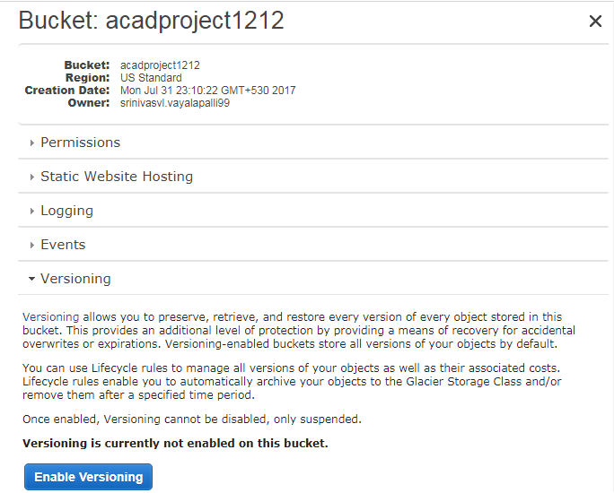

After creation of bucket, go to the properties of bucket and then click on versioning option. To enable versioning click on the “enable versioning”.

Without enabling the versioning we cann’t access lifecycle.

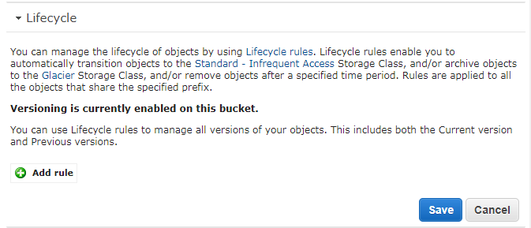

So to start work with lifecycle, click on add rules. Then it will redirect to next page.

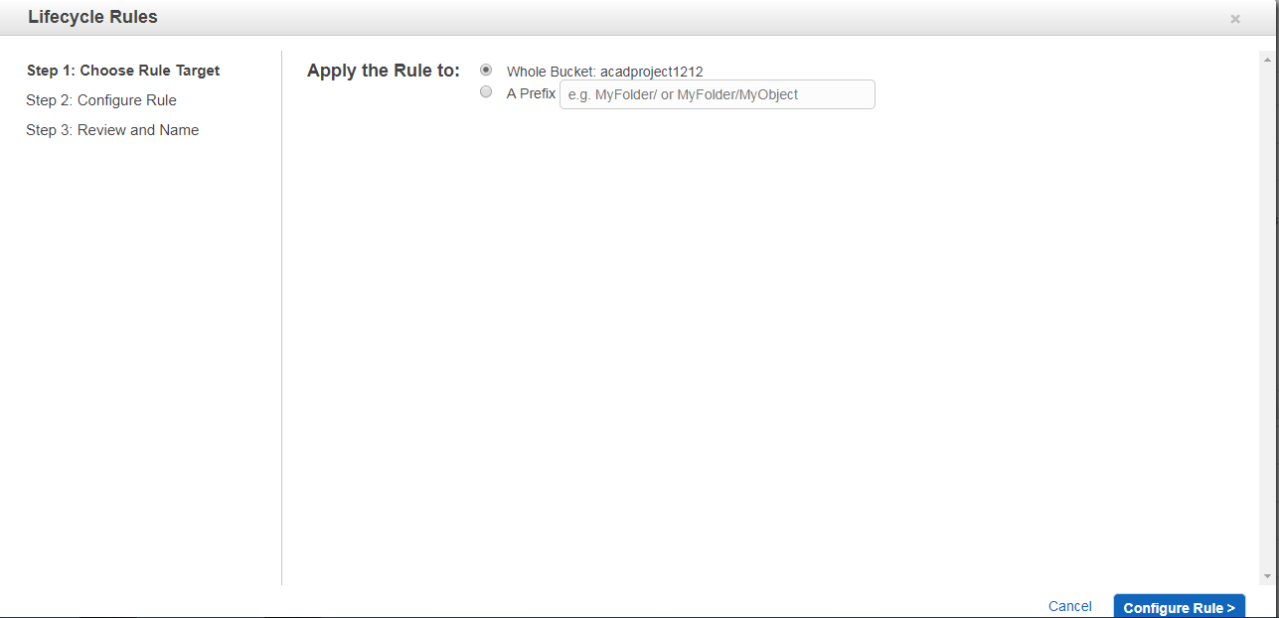

So select the option “whole bucket” to apply life cycle on all objects in that bucket.

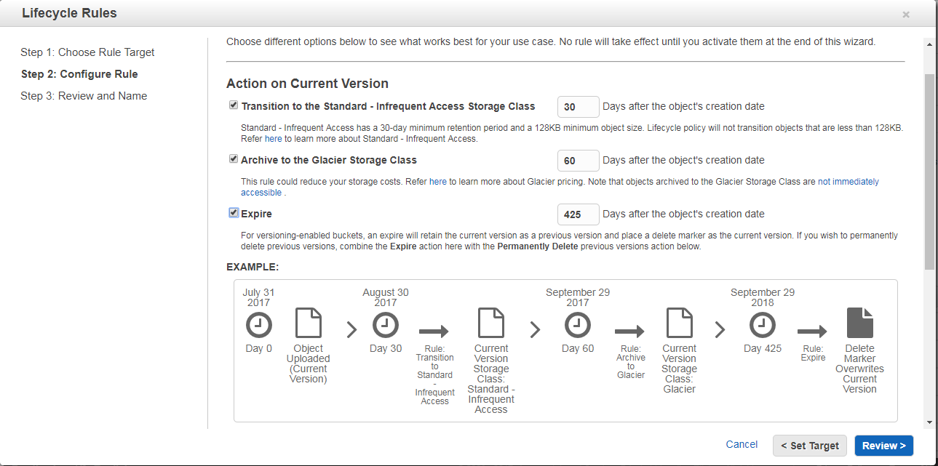

1)Action on current version:

After 30 days of object creation time it will move to the infrequent access storage class.

After 60 days of object creation time it will move into Archive to the Glacier storage class.

After 425 days of object creation time it will move into expire that object i.e that will permanently delete that object.

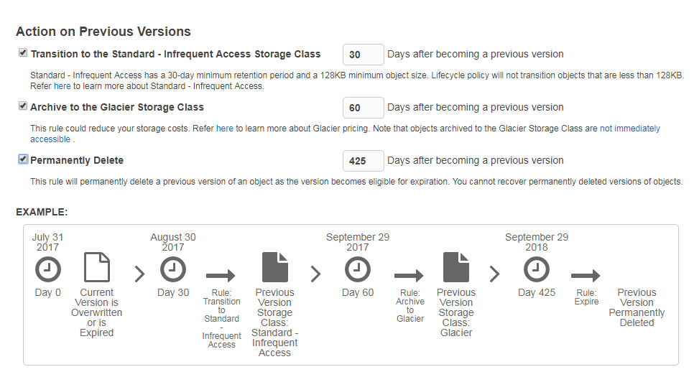

This is same as the previous one. But it will apply on the previous versions. First selected actions will apply on the updated versions.

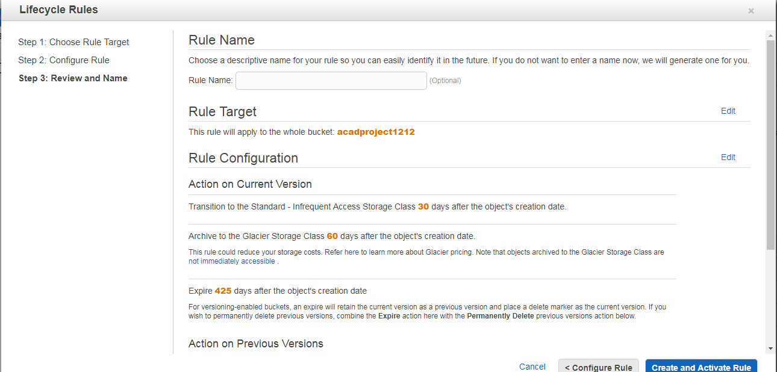

You can review the all actions before click on create button. If you are ok with that then simply click on create button to create the lifecycle rule.